**Prerequisites and dependencies**

To run the code, you will need the following dependencies: Cucumber.js, Axios, and Node.js. Please follow the step-by-step installation instructions provided below to install them.

**Prerequisites**

**Step 1: Ensure you have the following tools installed**

1. VS code (latest version) for IDE
2. Node.js

- To verify installation, run the following command in your Command Prompt:

node -v

npm -v

Below screen shot confirms the installation of Node.js

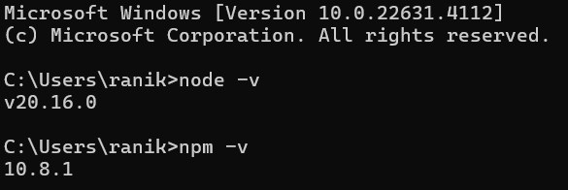

**Step 2: Set Up a New Project**

1. Create a new folder for project and navigate into it from VS code.
2. Initialise the project by running:

npm init -y

1. This will generate a “package.json” file with default settings. After installing all the dependencies, `package.json` file should look like the screenshot below.

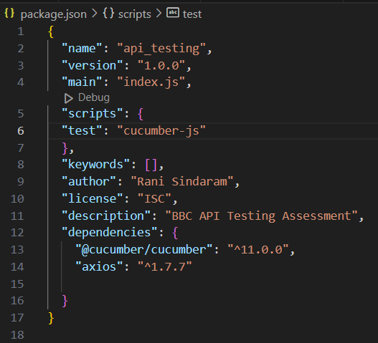

**Step 3: Install Dependencies**

Run the following commands to install required dependencies:

1. Install Cucumber.js:

npm install @cucumber/cucumber --save-dev

1. Install Axios (for making HTTP requests):

npm install axios

1. Install Assert:

npm install assert

**Step 4: Project structure**

1. After downloading the project folder from GitHub, the project structure should look like the screenshot shown below.

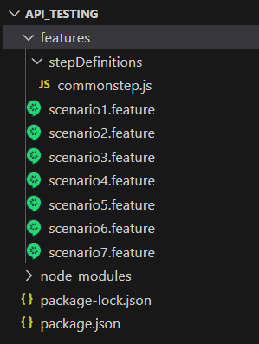

**Step 5: Execution**

1. Run Cucumber Tests:

- Run the tests by executing the following command in the root of the project directory:

npx cucumber-js

1. Check Output:

- On a successful run, the green checkmarks should appear if the tests pass.

- If test fails, the output will display detailed information about the failure.

**Summary of Installation Steps:**

1. Install Node.js and npm.
2. Initialize a new project using `npm init -y`.
3. Install the required dependencies (`@cucumber/cucumber`, `axios`, `assert`).
4. Create the `p2.feature` feature file and write the test scenario.
5. Create the `p2.steps.js` file with the step definitions.
6. Run the tests using `npx cucumber-js`.